2.5 Curvature

We will now explore the notion of curvature. We begin by reviewing some terminology.

Definition: A parameterization is called smooth on an interval I if is continuous and . A curve is smooth if it has a smooth parameterization. A smooth curve has no sharp corners or cusps.

Remark: For a smooth curve given by when the unit tangent vector, , turns it does so continuously.
When a smooth curve has sharp turns will turn quickly. When a curve turns quite slowly, will not turn quickly. Consider the pictures below for examples of this idea.

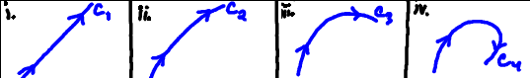

This leads to the following definition.

Definition: The curvature of a smooth curve is .

Theorem: The curvature of a smooth curve given by can be expressed as
- .
OR

Proof: We will prove (2). A proof of (1) is available in Blackboard.

Note: Part (b) of this theorem will tend to be more useful since it only requires that we know the vector-valued function , we don’t need to compute the tangent vector , and we can easily change the parameter if needed.

Example 1: Consider the circle given by where and . Find the curvature of this circle.

Example 2: Let C be the ellipse oriented counterclockwise. Measure the curvature at each endpoint of its major and minor axes.

